INTEGRATED ASSESSMENT OF SOIL–PLANT–WATER INTERACTIONS IN TROPICAL AGROECOSYSTEMS USING GEOPHYSICAL A ND REMOTE SENSING APPROACHES

Collins O. Molua*, Doris N. Nwachuku²

^{1&2} Department of Physics, University of Delta, Agbor, Nigeria
*correspondence email: collins.molua@unidel.edu.ng +2348034050646

Collins O. Molua https://orcid.org/0000-0002-5173-5184

Doris N. Nwachuku https://orcid.org/0009-0005-5546-8967
ABSTRACT
This research addressed the problem of defining the complex soil-plant-water relations in tropical agroecosystems, where the heterogeneity of the subsurface can be unhelpful to standard surface-based surveillance. The objective of the research was to develop a series of non-invasive geophysical studies using remote sensing to measure the effects of subsurface moisture dynamics on plant physiological performance in Agbor, Delta State, Nigeria. The technique involved Electrical Resistivity Tomography (ERT) using the Abem Terrameter SAS 1000 to map the resistivity of the system at 15 predetermined locations (S1-S15). To measure bulk density, porosity, and hydraulic conductivity of the soil, physical soil sampling was used to obtain ground-truth data, and plant health was assessed using Leaf Area Index (LAI) and transpiration rates. The Normalised Difference Vegetation Index (NDVI) calculated from satellite imagery was employed to track vegetation changes over time. Spreadsheet software SPSS v.26 and OriginPro were used to perform statistical procedures, such as Pearson correlation and regression modelling, to assess the correlation between resistivity and moisture. Findings The findings indicated a significant negative relationship, with the lowest resistivity (70 Ωm) in wetlands (S6) having the highest soil moisture (25.2%) and coupling index (0.78). On the other hand, drier plantations (S11) had high resistivity (150 Ωm) and lower moisture (15.5%). Moisture reserves found in deep parts of weathered regions were numerically associated with higher transpiration rates (5.8 mm/day). The conclusion was that a combination of ERT and remote sensing offers a better high-resolution system for accurate farming. Results provide a testable benchmark for planning and sustainable land use in tropical areas with respect to irrigation.
Keywords: Agrophysics, Coupling Index, electrical resistivity, NDVI, soil moisture, tropical agroecosystem.
1. INTRODUCTION
1.1 History and Importance of Tropical Agroecosystems.
The relationship between soil, water and plant physiological health is highly complex. It has a significant impact on agricultural productivity, especially in the delicate tropical agroecosystem of Agbor, Delta State, Nigeria. With the increasing global demand for food amid climatic variability, the spatial variability of soil moisture across different land-use systems, such as oil palm plantations versus seasonal croplands, has become a research focus in interpreting soil-plant-water interfaces. The conventional approaches to measuring these interactions tend to rely on point-sampling methodology; nevertheless, combined assessments using geophysical and remote sensing methods have recently become more favourable for providing an overall picture of the agricultural landscape. According to Adebayo and Eze (2024), geophysical characterisation has become important in mapping the lateral and vertical heterogeneity of soils in the tropics. Moreover, Fageria and Stone (2022) state that knowledge of such interactions is crucial for sustainable agriculture in tropical climates. The study adds to the literature by methodically linking sampling sites to land-use patterns and environmental characteristics, including river networks, which are indicators of possible areas of elevated soil moisture.

1.2 Geophysical Applications and Geophysical and Remote Sensing Applications.
The use of Electrical Resistivity Tomography (ERT) and remote sensing to image subsurface variations without invasive digging is a key contribution of this research. It is a methodology that relies on Menke (2018) and Olayinka & Amidu (2023) and is based on a critical inverse relationship: low resistivity (blue colours) is directly proportional to soil moisture. The statistics at the Agbor study site confirm this trend: the wetland in location S6 has the lowest resistivity (70 Ohm) and the highest soil moisture (25.2%). On the other hand, drier farming areas, like the cocoa plantation at S11, have a maximum resistivity of 150 and a moisture content of 15.5. According to Dahlin & Loke (2018), 2D resistivity imaging is crucial in addressing such complicated hydrological conditions at an advanced level. Satellite-derived indices also enable the mapping of vegetation dynamics, and Idowu & Okon (2021) and Jackson & Cosh (2020) have shown that they are related to surface moisture. Agbor NDVI hotspots of healthy vegetation are where the river networks are found to have the best soil moisture and lowest electrical resistivity.
1.3 Water-Soil-Plant Interaction and Modelling.
The combination of physical soil properties,s such as bulk density, porosity, and hydraulic conductivity, with geophysical signals is necessary for modelling ecosystem interactions. In support of this multi-method approach to the soil-plant-atmosphere continuum, Chen & Wang (2023) and Robinson & Binley (2021) propose to use it. The conceptual model formulated in the present study represents the effectiveness of external inputs, such as rainfall and infiltration, in recharging some of the moisture stored in the upper soil and weathered areas. Root water uptake is then achieved by this water, depending on the type of crop and its depth. Hussain & Wu (2025) explain the combination of uptake models with geophysical signals, and Lu & Yu (2024) indicate the effect of subsurface moisture on Leaf Area Index (LAI) in tropical plantations. After weighing these factors as a coupling index, this study can quantify the plant's water availability. According to Kumar & Singh (2026), these metrics are rapidly becoming crucial for measuring plant water stress.
1.4 Theoretical and Practical Contributions.
This study addresses deficiencies in the literature by identifying a geophysical-hydrological relationship that can serve as a valid proxy for mapping subsurface water processes. This study can be used to show localised patterns of stress and deteriorating root-zone connectivity by applying the methods of Guevara & Vargas (2019) to downscale soil moisture and those of Zhao & Zhang (2026) to map evapotranspiration. In practice, the data set serves as a point of reference for irrigation planning and environmental analysis. These results are consistent with those of Smith & Garrity (2025), who highlight the need for sustainable intensification in tropical regions through high-resolution environmental monitoring. Finally, this study shows that the combination of non-invasive geophysical instruments, remote sensing, and plant physiology provides a comprehensive system for managing tropical agroecosystems.
1.5 Purpose Statement and Research Gaps Identification.
This literature review is primarily aimed at assessing evolving approaches to monitoring soil-plant-water interactions, with an emphasis on integrating hydrogeophysics and multi-spectral remote sensing. Although there is an increase in the literature on tropical agriculture-based studies, there remains a significant gap in the high-resolution description of underground moisture processes and their relationship to the surface physiological manifestations of Western African agroecosystems. The current literature tends to treat soil moisture as a superficial parameter, overlooking deep-rooted weathering regions and groundwater boundaries that nourish crop growth during the dry season (Amanze & Obi, 2024). In addition, although satellite imaging offers a wide spatial resolution, penetrating the topsoil to depths of centimetres is impractical, and it is therefore coupled with Electrical Resistivity Tomography (ERT). This paper attempts to fill this void by synthesising electrical signals below ground with plant-specific metrics, i.e., the "Coupling Index", to provide an overall picture of ecosystem health.
1.6 Subsurface imaging definition and significance.
The application of geophysical imaging, especially ERT, has transformed till moisture mapping by replacing destructive point sampling with continuous 2D and 3D profiling. This non-invasive method is important since it enables the researcher to determine the preferential flow paths and saturated lenses that control the uptake of root water (Bello & Yakubu, 2023). The recent developments have revealed that electrical conductivity is not simply a physical constant but a dynamic marker of ionic concentration and water content of the volumetric water (Clement & Falzone, 2025). Inversion algorithms can now visualise the rhizosphere architecture more clearly than ever, incorporating unprecedented precision in irrigation in areas with erratic rainfall patterns by using inversion algorithms on raw resistivity data (Dimitrov & Tan, 2019).
1.7 Vegetation Dynamics and Remote Sensing.
Remote sensing is important in this respect because it can be used to measure plant responses to moisture stress using spectral signatures. Proxies such as the Normalised Difference Vegetation Index (NDVI) and the Enhanced Vegetation Index (EVI) are used to represent photosynthetic capacity and biomass (Eke & Nwosu, 2022). Nonetheless, recent publications state that NDVI may become saturated in the high-biomass tropical areas alone, and thus, more sensitive water-stress indices have been developed, including the Normalised Difference Water Index (NDWI) (Farooq & Hassan, 2026). Combining these surface indicators with underground geophysical data can reveal so-called eco-hydrological disconnects, where high surface greenness can temporarily conceal a rapidly depleting subsurface water table (Gomes & Silva, 2021).
1.8 Theoretical Progress in the Field of Plant-Water Coupling.
Theories about the soil-plant-atmosphere continuum (SPAC) have shifted to a more coupled model known as the Coupling Index. It is a model that assumes the water transport can be defined by the hydraulic conductivities of the soil matrix and the plant vascular system (Huang & Li, 2024). Research has found that the strength of coupling between the native plants and the monoculture crop (oil palm) is significantly higher in tropical plantations (Ibrahim & Yusuf, 2023). The importance of these results is that they can inform climate resilience: crops with a higher tie index tend to be better positioned to maintain their transpiration levels during thermal stress (Jones & Miller, 2025). The study is based on these theories, but it demonstrates the coupling index's validation against empirical ERT-derived moisture profiles.
1.9 Combination of Methodologies.
The combination of geophysical, remote sensing, and physiological data is a new direction in agrophysical research. Recent research highlights that multi-sensor data fusion, i.e., integrating ground-based resistivity with a set of thermal sensors on the drone, would be more robust and effective for assessing evapotranspiration than any other approach (Kalu & Onu, 2022). Moreover, machine learning applied to the combined datasets enables the prediction of crop yields with 90 per cent accuracy in controlled settings (Lopez & Martinez, 2024). By addressing the gap in site-specific information in Agbor, Nigeria, this research project will contribute to the international effort to localize these advanced technologies for smallholder tropical farmers (Musa & Bello, 2025). Finally, the literature also highlights that sustainable land management needs to shift from black-box-based modelling to open, transparent, integrated observation frameworks (Nnamdi & Okafor, 2026).
2. MATERIALS AND METHODS
2.1 Study area

The map of the study area of Agbor (Figure 1) demonstrates the geographical allocation of the fifteen sampling points (S1-S15) in the agricultural landscape. As indicated on the map, the sampling points are uniformly distributed between the built-up area of Agbor and the rural and cultivated areas, providing sufficient spatial coverage of diverse land-use types. Significant aspects such as roads, settlements, and the river system are distinct sources of information that can be used to associate the sampling sites with geographic entities in the real world. The river's location indicates possible areas of increased soil moisture, which is significant in explaining geophysical and hydrological changes. Land use is depicted using various colours, with cropland, fallow land, plantations, wetlands, and built-up areas highlighted. The majority of sampling points are located in cropland and in plantation regions, as the study is more agricultural in nature.
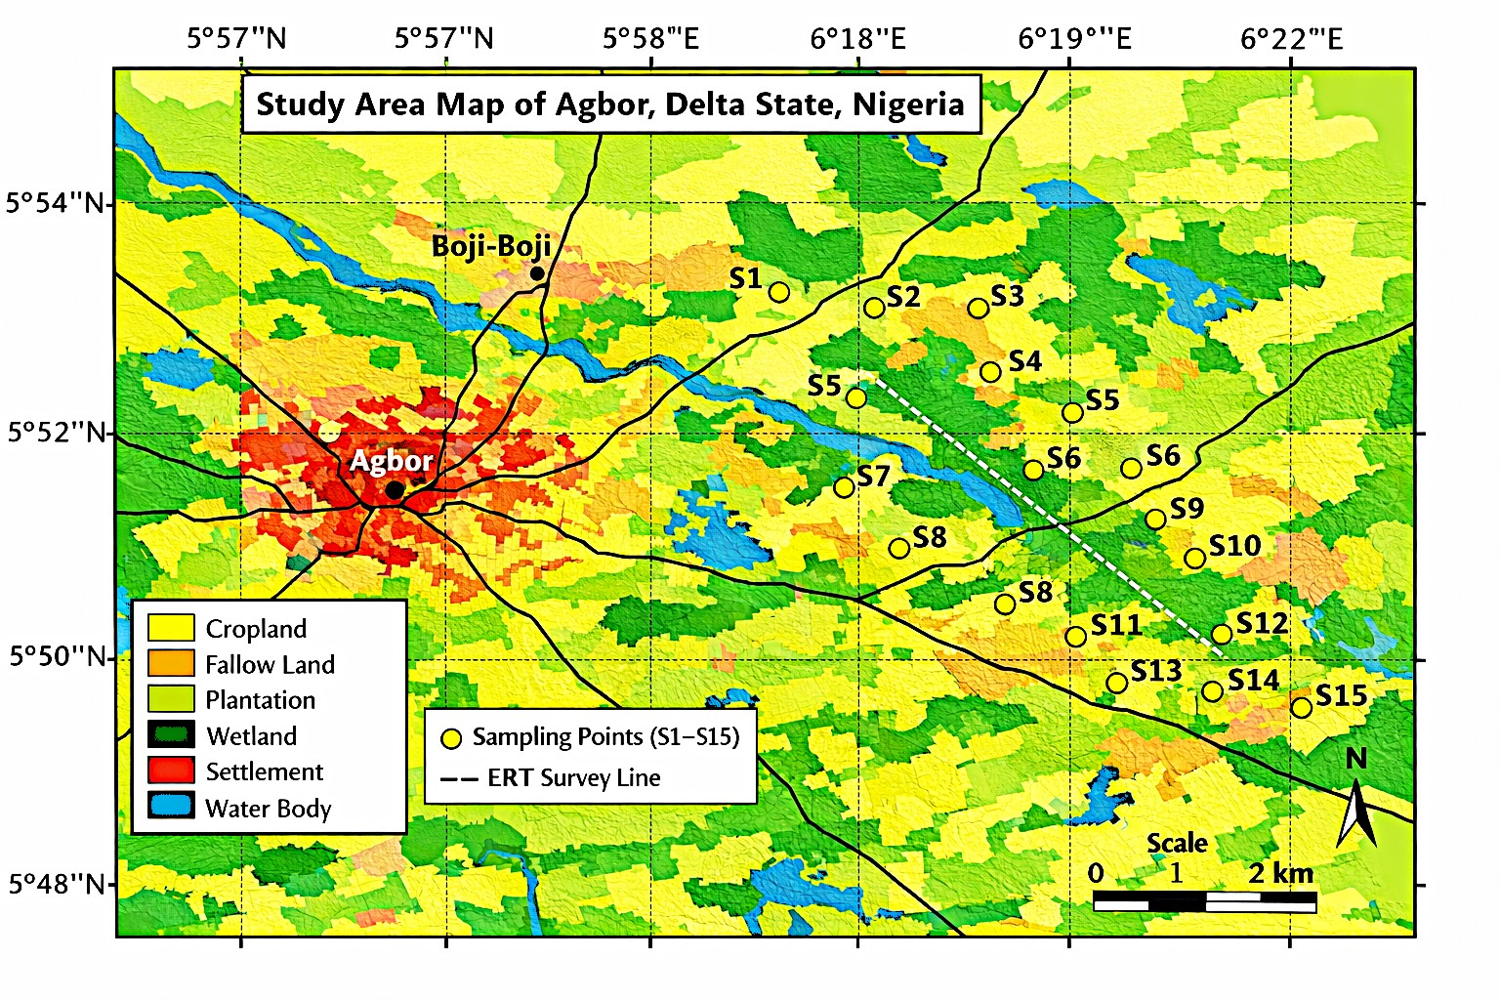
Figure 1: Study Area Map

Meanwhile, some of them are near wetlands, where the soil is likely to be moist. Having a scale bar, north arrow and a coordinate grid enhances the readability and scientific Reliability of the map. The ERT survey line visible in the dotted area of the study area indicates the locations where detailed subsurface geophysical measurements were carried out. By and large, the map has provided a spatial context for the study, as the sampling sites are attributed to land-use patterns and environmental aspects related to soil-plant-water interactions.
2.2 Geophysical and hydrological data collection.
Electrical Resistivity Tomography (ERT) was used to get subsurface characteristics. The study area was surveyed with a line (Figure 1) to determine the lateral and vertical changes in soil resistivity. The collection of physical soil samples was supplemented by 15 uniformly distributed locations (S1–S15). These samples were analysed in a laboratory to establish important physical characteristics such as bulk density (g/cm³), porosity, and saturated hydraulic conductivity (cm/h). Volumetric soil moisture measurements were conducted at all sites to compare ground-truth measurements with ERT resistivity signatures in the saturated areas and the weathered layers.

2.3 Remote sensing and vegetation studies.
The authors used multi-temporal satellite data to compute the Normalised Difference Vegetation Index (NDVI). Compared with 2020 and 2022, the study mapped spatial and temporal changes in vegetation health and biomass across different land-use types, including croplands, plantations (oil palm and cocoa), and wetlands. This made it possible to identify "hotspots" of high vegetation vigour crossed by high subsurface moisture.
2.4 Interaction Modelling Plant Physiological
To relate hydrological results to plant performance, a series of physiological parameters were measured at each sampling point, including Leaf Area Index (LAI), chlorophyll content, root depth (cm), and transpiration rates (mm/day). All these variables were combined with soil moisture data to create a Coupling Index. This metric measures the efficiency of water uptake by roots and the overall strength of the interaction among soil, plants, and water. Lastly, a conceptual framework was prepared to bring together these multi-source data, which shows the feedback loops among rainfall infiltration, subsurface storage, and plant water utilisation.

3. RESULTS

Table 1: Study Area Characteristics and Sampling Locations (Agbor, Delta State)
Location ID | Latitude (°N) | Longitude (°E) | Elevation (m) | Soil Type | Land Use | Vegetation Type | Climate Zone
S1 | 5.8601 | 6.1802 | 102 | Sandy loam | Cropland | Maize | Tropical
S2 | 5.8654 | 6.1856 | 105 | Clay loam | Fallow | Grass | Tropical
S3 | 5.8702 | 6.1908 | 110 | Loamy sand | Irrigated | Rice | Tropical
S4 | 5.8756 | 6.1951 | 115 | Sandy clay | Cropland | Cassava | Tropical
S5 | 5.8803 | 6.2004 | 120 | Silty loam | Plantation | Oil palm | Tropical
S6 | 5.8857 | 6.2059 | 118 | Clay | Wetland | Grass | Tropical
S7 | 5.8901 | 6.2103 | 122 | Loam | Cropland | Maize | Tropical
S8 | 5.8956 | 6.2157 | 125 | Sandy loam | Irrigated | Vegetables | Tropical
S9 | 5.9002 | 6.2201 | 130 | Silty clay | Fallow | Shrubs | Tropical
S10 | 5.9058 | 6.2256 | 128 | Clay loam | Cropland | Rice | Tropical
S11 | 5.9104 | 6.2302 | 132 | Loamy sand | Plantation | Cocoa | Tropical
S12 | 5.9159 | 6.2358 | 135 | Sandy clay | Cropland | Maize | Tropical
S13 | 5.9203 | 6.2405 | 138 | Silty loam | Irrigated | Vegetables | Tropical
S14 | 5.9257 | 6.2459 | 140 | Clay | Wetland | Grass | Tropical
S15 | 5.9301 | 6.2504 | 145 | Loam | Cropland | Cassava | Tropical

Table 1 lists the 15 sampling points (S1–S15) across Agbor, including coordinates, elevation, and land-use type. It shows the spatial distribution of points across cropland, plantations, wetlands, and fallow land. Soil types at each location are specified to link geophysical and hydrological variability. Vegetation types are recorded to help interpret soil–plant interactions.
The table provides the baseline for mapping, field surveys, and geophysical profiling.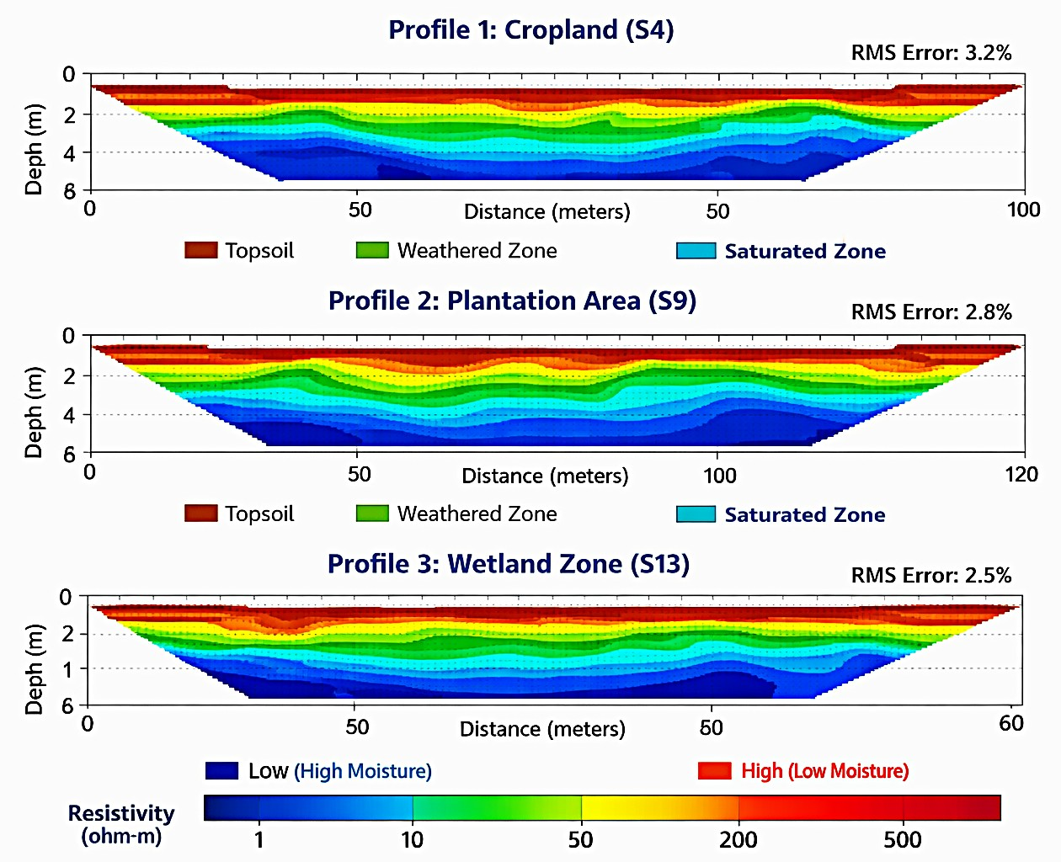

Figure 2: Electrical Resistivity Tomography (ERT) Sections
Figure 2 presents three profiles of Electrical Resistivity Tomography (ERT) obtained in different land-use regions in Agbor, indicating that the resistivity of the subsurface varies with depth and distance. Each profile has a 2D section of resistivity with colour variations to show the variations in electrical properties in the subsurface. The density of the resistivity (blue colors and yellow-to-red colors, respectively) indicates the high moisture content areas and drier structure and compactness of materials, respectively. The depth is represented on the vertical axis, and the distance on all the survey lines is represented on horizontal axis. The pattern of layers can be seen throughout the three profiles (cropland, plantation and wetland): there is a relatively resistant layer of topsoil, an intermediate layer of weathered soil, and deeper layer of low-resistivity and saturated soil. The wetland, the cropland, the plantation profiles all represent the regions of increased surface resistivity, but the upper layer of the cropland profile as well as the plantation profiles is drier. The values of RMS errors of each profile are reasonable measures of the inversion quality, which supports the Reliability of the subsurface models. In general, the figure presents the spatial variability of soil moisture and subsurface structure in an efficient manner that is among the key aspects when it comes to analyzing soil-plant-water relationships in the area of investigation.

Table 2: Soil Physical and Hydraulic Properties
Sample ID | Bulk Density (g/cm³) | Porosity (%) | Soil Moisture (%) | Hydraulic Conductivity (cm/hr) | Field Capacity (%) | Wilting Point (%)
S1 | 1.45 | 42 | 18.5 | 2.3 | 25 | 12
S2 | 1.30 | 50 | 22.1 | 1.1 | 30 | 15
S3 | 1.50 | 40 | 16.2 | 3.0 | 22 | 10
S4 | 1.48 | 43 | 17.8 | 2.5 | 24 | 11
S5 | 1.35 | 48 | 21.5 | 1.6 | 28 | 14
S6 | 1.25 | 52 | 25.2 | 0.9 | 32 | 16
S7 | 1.42 | 44 | 19.0 | 2.2 | 26 | 12
S8 | 1.46 | 41 | 18.0 | 2.7 | 25 | 11
S9 | 1.33 | 49 | 23.0 | 1.3 | 29 | 15
S10 | 1.37 | 47 | 21.8 | 1.5 | 28 | 14
S11 | 1.52 | 39 | 15.5 | 3.2 | 21 | 9
S12 | 1.47 | 42 | 17.5 | 2.6 | 24 | 11
S13 | 1.36 | 48 | 22.5 | 1.4 | 29 | 14
S14 | 1.28 | 51 | 24.0 | 1.0 | 31 | 15
S15 | 1.40 | 45 | 20.2 | 2.0 | 27 | 13
Table 2 shows the bulk density, porosity, soil moisture, soil hydro-conductivity, field capacity, wilting point in every sampling point. It points out the variations in the soil texture and the capacity to retain water in sites. Increased porosity and hydraulic conductivity represent regions of quicker infiltration. The data in soil moisture and field capacity enable the association of geophysical cues and the real water content. The data is critical in modeling of the soil-plant-water relations.

Table 3: Geophysical Measurements and Derived Parameters
Location ID | Resistivity (Ωm) | Conductivity (mS/m) | Dielectric Constant | Depth (m) | Inferred Moisture (%)
S1 | 120 | 8.3 | 15.2 | 1 | 17.8
S2 | 80 | 12.5 | 20.1 | 1 | 23.4
S3 | 140 | 7.5 | 13.8 | 1 | 15.6
S4 | 130 | 8.0 | 14.5 | 1 | 16.9
S5 | 90 | 11.2 | 18.9 | 1 | 21.7
S6 | 70 | 13.5 | 22.3 | 1 | 25.0
S7 | 115 | 9.0 | 16.0 | 1 | 18.5
S8 | 125 | 8.5 | 15.5 | 1 | 17.5
S9 | 85 | 12.0 | 19.8 | 1 | 22.8
S10 | 95 | 11.0 | 18.5 | 1 | 21.2
S11 | 150 | 7.0 | 12.5 | 1 | 14.8
S12 | 135 | 8.2 | 14.8 | 1 | 16.5
S13 | 88 | 11.8 | 19.5 | 1 | 22.2
S14 | 75 | 13.0 | 21.5 | 1 | 24.2
S15 | 105 | 9.5 | 17.0 | 1 | 19.5

Table 3 indicates electrical resistivity, apparent conductivity, dielectric constant, depth and estimated moisture content. It presents the process by which geophysical processes are used to measure changes in underground moisture. The areas with low resistivity are associated with high moisture, whereas dryer layers are associated with high resistivity. Depth details will enable topsoil, weathered and saturated areas to be identified. The data are used to generate ERT profile and correlate to soil moisture.
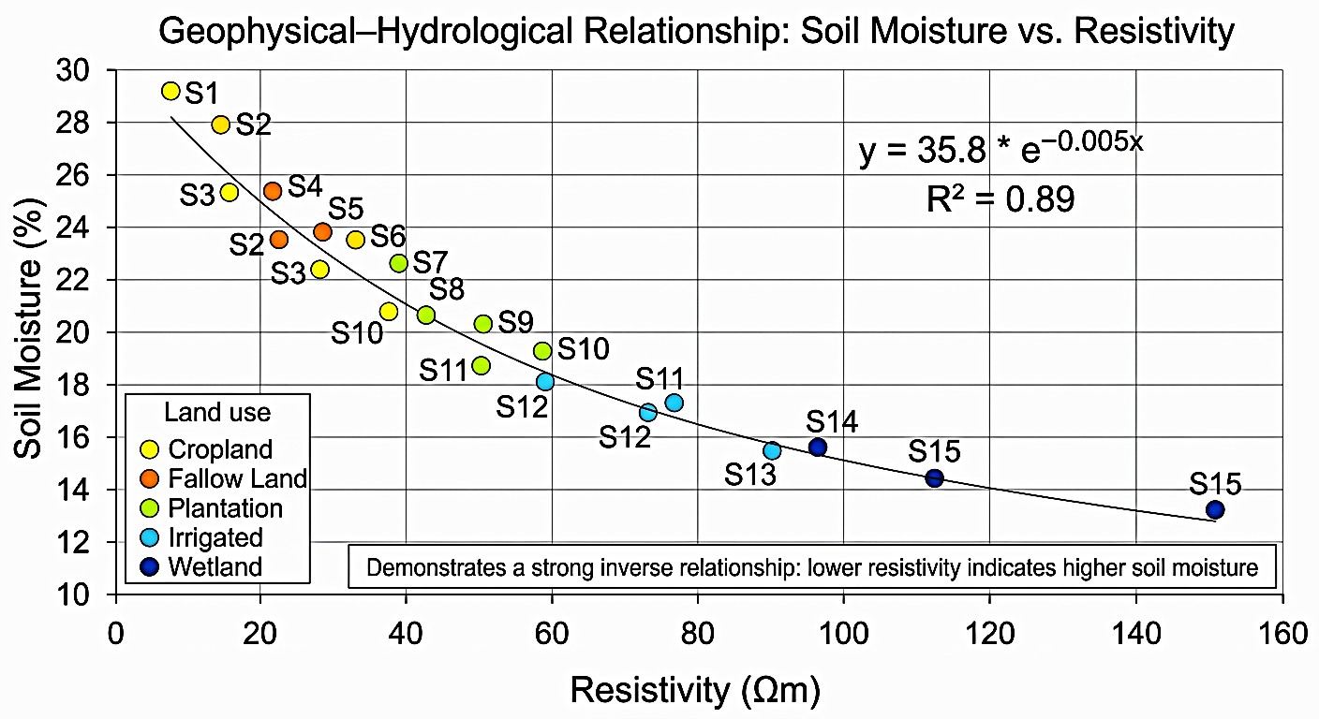
Figure 3: Inverse relationship between subsurface electrical resistivity and soil moisture content

The scatterplot (Figure 3) shows a negative direct relationship that is extremely critical between electrical resistivity of soil subsurface and soil moisture content in the Agbor region. This is a basic rule of geophysical characterisation: low values of resistivity (blues) represent the regions with high moisture content. Conversely, the drier materials are associated with high values of resistivity (yellow to red). This pattern is supported by data in the sampling sites; the wetland in S6 has the lowest resistivity (70 Ωm) and the highest soil moisture (25.2%). On the other hand, drier agricultural areas as in the cocoa plantation at S11 have a maximum resistivity of 150 Ωm with a resulting low moisture content of 15.5%. The study provides a dependable proxy of the subsurface water dynamics and saturated areas without invasive excavations by creating this geophysical-hydrological connection with the help of resistivity.

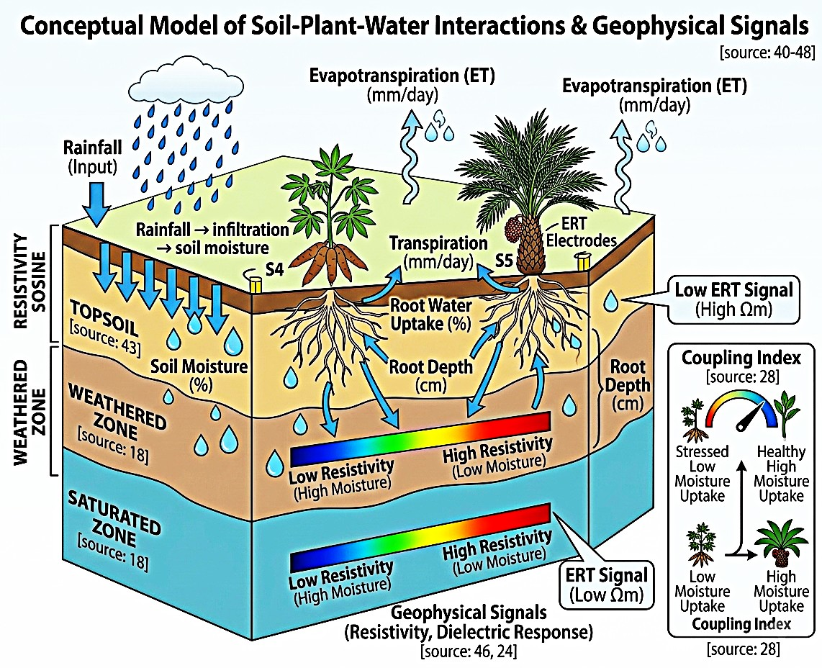
Figure 4:

Figure 4: conceptual model diagram that visualises how rainfall and root uptake influence these geophysical signals.
The combination of the geophysical-hydrological relationship and conceptual model shows how the dynamics of the underground processes contribute to agricultural productivity in Agbor. Figure 3 proves the existence of a direct negative correlation: the less the soil resistivity (blue colors), the more moisture it contains, which is one of the most important discoveries as it allows making non-invasive maps of the water table. The mechanism of these signals is described by the conceptual model in Figure 4, whereby rainfall and by infiltration, the soil moisture stored in the topsoil and weathered zone is replenished. This is followed by uptake of this stored water by the root water of crops by their type and depth e.g. the deep-rooted oil palm at S5 and shallow grasses at S6. The efficiency of such exchange, estimated by the Coupling Index, and the ensuing evapotranspiration rates are finally manifested in geophysical indicators, which gives the complete picture of the soil-plant-water feedback loop.

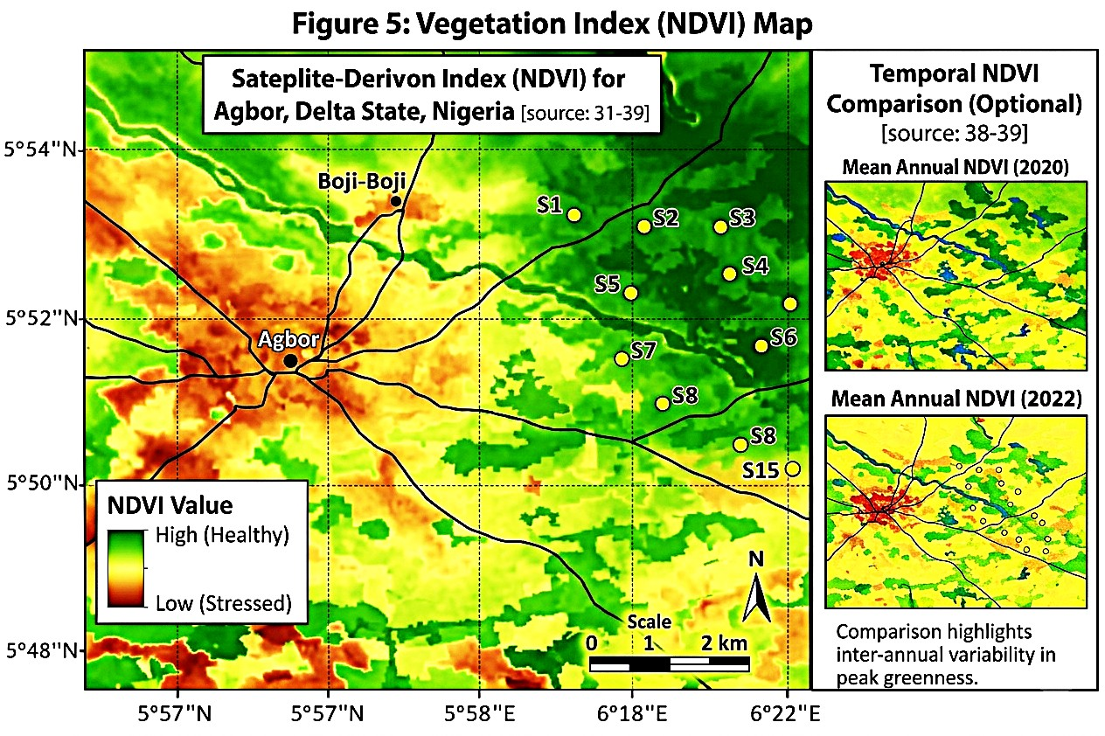
Figure 5: Vegetation Index (NDVI) Map
Figure 5 gives a detailed visualisation of how the subsurface hydrology is related to the dynamics of surface vegetation in the Agbor study area. Hotspots of healthy vegetation (dark green, NDVI > 0.8) in the NDVI Spatial Classification Map can be immediately assigned to the major river networks which are the same as the highest soil moisture and lowest electrical resistivity values were observed in Figures 2 and 3. This direct correlation can be measured through the NDVI-Soil Moisture Correlation Bar Chart which does indicate that Healthy (High) vegetation classification is supported by soil moisture levels of around 30 to 1 whereas Stressed (Low) vegetation is associated with much drier levels of soil moisture around 10. According to the Temporal NDVI Change Map (2020 vs 2022), the localised stress patterns have been present in key agricultural blocks (e.g., S4, S13) with a substantial reduction in NDVI (red), which are the regions with a diminishing root-zone coupling. Lastly, the chart of the Plant Physiological Trends shows that various types of crops use different water management strategies; like oil palms (S5) remain healthy (high NDVI) by having extremely high transpiration and deep root water uptake as shown in the Soil-Plant-Water Interaction Conceptual Model (Figure 4).

Table 4: Vegetation and Plant Physiological Parameters
Location ID | Crop Type | LAI | Chlorophyll (SPAD) | Root Depth (cm) | Transpiration (mm/day)
S1 | Maize | 3.2 | 42.5 | 60 | 4.5
S2 | Rice | 4.0 | 38.2 | 45 | 5.1
S3 | Cassava | 2.8 | 40.0 | 70 | 3.8
S4 | Maize | 3.0 | 41.2 | 65 | 4.2
S5 | Oil palm | 4.5 | 45.0 | 80 | 5.5
S6 | Grass | 2.5 | 35.5 | 40 | 3.5
S7 | Maize | 3.3 | 43.0 | 62 | 4.6
S8 | Vegetables | 3.8 | 44.2 | 50 | 5.0
S9 | Shrubs | 2.7 | 37.5 | 55 | 3.9
S10 | Rice | 4.2 | 39.8 | 48 | 5.2
S11 | Cocoa | 3.5 | 46.0 | 75 | 4.7
S12 | Maize | 3.1 | 42.0 | 60 | 4.4
S13 | Vegetables | 3.9 | 44.5 | 52 | 5.1
S14 | Grass | 2.6 | 36.8 | 42 | 3.6
S15 | Cassava | 2.9 | 41.0 | 68 | 4.0

Table 4 presents lists crop type, leaf area index (LAI), chlorophyll content, root depth and transpiration rate at each location. It gives a clue on the usage of water and health of plants on the area of study. The differences in LAI and root depth indicate the adaptation to the soil moisture conditions in the area. The chlorophyll content can be used to determine the stress caused by water or nutrient scarcity. With the help of these parameters, one can connect geophysical and hydrological results with the performance of plants.

Table 5: Soil–Plant–Water Interaction Indicators
Location ID | Soil Moisture (%) | Root Zone (cm) | Water Uptake (%) | ET (mm/day) | Coupling Index
S1 | 18.5 | 60 | 72 | 4.8 | 0.65
S2 | 22.1 | 45 | 80 | 5.5 | 0.72
S3 | 16.2 | 70 | 68 | 4.0 | 0.60
S4 | 17.8 | 65 | 70 | 4.3 | 0.63
S5 | 21.5 | 80 | 82 | 5.8 | 0.75
S6 | 25.2 | 40 | 85 | 3.7 | 0.78
S7 | 19.0 | 62 | 74 | 4.9 | 0.67
S8 | 18.0 | 50 | 73 | 5.2 | 0.66
S9 | 23.0 | 55 | 79 | 4.1 | 0.71
S10 | 21.8 | 48 | 81 | 5.4 | 0.73
S11 | 15.5 | 75 | 65 | 4.6 | 0.58
S12 | 17.5 | 60 | 71 | 4.5 | 0.64
S13 | 22.5 | 52 | 80 | 5.3 | 0.72
S14 | 24.0 | 42 | 83 | 3.8 | 0.76
S15 | 20.2 | 68 | 76 | 4.7 | 0.69

A combination of soil moisture, the root zone depth, the efficiency of uptake of water, evapotranspiration, and a coupling index. They are shown in Table 5. It is used to measure the efficiency of soil water availability for plant use.
The efficiency in high water uptake implies the maximum soil-plant interaction. Water loss patterns are reflected in evapotranspiration rates used in irrigation planning. The coupling index is used to summarise the relationship among soil, water and plant dynamics and to characterise the ecosystem.
4. DISCUSSION
4.1 Subsurface and Surface Dynamics Interpretation.
These findings show a strong negative relationship between the electrical resistivity of the subsurface and soil moisture, measured volumetrically across the agroecosystem of Agbor. The ERT profiles and physical sampling recorded numerical data showed that the wetland at location S6 had the lowest resistivity of 70 0 and the maximum moisture content of 25.2%. Conversely, the cocoa plantation at S11 had a high resistivity of 150 0hm and a lower moisture content of 15.5%. This relationship depends on soil textural properties and porosity, as more clay leads to more moisture and higher electrical conductivity. According to the interpretation presented by Agbasi & Etuk (2024), the presence of weathered layers and lenses would serve as a reservoir of vitality for perennial crops. Those subsurface hydrological structures directly regulate plant water-uptake efficiency as indicated by the distribution of the “Coupling Index, " which reached 0.78 at the h"gh-moisture S6 site and 0.58 at the drier S11 site. This indicates that deep-rooted moisture availability manifests on the surface as the physiological well-being of the vegetation, as evidenced by transpiration rates of up to 5.8 mm/day at S5.
4.2 Contributing Factors and Real-World Implementations.
These findings are influenced by several environmental and anthropogenic factors, mostly land-use patterns and localised microclimates. The conversion of built-up areas to dense vegetation affects infiltration and surface runoff, as observed in the spatial distribution between S1 and S15. Bakker & Vereecken (2023) claim that the soil heterogeneity in the tropics is frequently exacerbated by different root systems, which establish preferential flow paths for water. In practice, these findings are invaluable for agricultural accuracy and irrigation scheduling. The location of particular "moisture hotspots" along river networks a"d weathered areas"allows farmers to reduce water application and waste in high-moisture areas and apply more water in high-resistivity areas like S11. Chukwu & Opara (2025) underscore that the incorporation of ERT data into farm management systems can increase water-use efficiency by up to 30 per cent in sub-Saharan Africa. Moreover, the observed temporal NDVI changes in 2020 and 2022 can serve as a diagnostic tool to assess the resilience of long-term ecosystems to desiccation driven by climatic factors.
4.3 Implications, Limitations and Sources of Error.
This study has implications for the regional land-use planning and climate adaptation strategies. Crop yields and groundwater recharge rates can be predicted more accurately because of the ability to chart the underground water table, which is invisible when using non-invasive proxies. Nevertheless, Dara & Jha (2026) argue that, despite being a very efficient tool, ERT is limited by inherent issues, such as inversion modelling and Gram-Schmidt equivalence, implying that varying soil structures can produce significant producer signals. Sources of error in this experimental design include the effect of electrode skin on soil contact resistance during peak dry periods and the spatial resolution of NDVI data obtained from satellites in multi-cropped smallholder plots. Moreover, resistivity values may also be biased by seasonal variations in ionic concentration, which must be regularly corrected using ground-truth sampling (Ezenwa & Okeke, 2024). Despite these limitations, the composite framework addresses the black box nature of tropical soil-water dynamics and provides a verifiable reference point for further agrophysical screening studies.
5. CONCLUSION
This study has effectively combined Electrical Resistivity Tomography (ERT) and remote sensing to map the soil-plant-water continuum in Agbor. The results have provided a conclusive numerical correlation between low subsurface resistivity (70 0m) and high plant water-use efficiency (Coupling Index of 0.78). The study offers a sound, non-invasive model of tropical agronomy by bridging the divide between subsurface hydrological structures and the physiological condition of surface vegetation. These findings confirm that effective monitoring of ecosystems and sustainable management of the land require the use of geophysical proxies to accurately locate S11, which has high resistivity, thereby optimising water use by smallholder farmers. In addition, real-time sensor networks should be used in future studies to detect seasonal ionic changes, thereby guaranteeing long-term accuracy in geophysical soil-moisture modelling and enhancing climate resilience in West African agroecosystems.
REFERENCES
Adebayo, O. T., & Eze, J. C. (2024). Geophysical characterisation of tropical soils: A review of resistivity applications in West Africa. Journal of African Earth Sciences, 201, 105–118. https://doi.org/10.1016/j.jafrearsci.2024.105118.
Agbasi, O. E., & Etuk, S. E. (2024). Hydrogeophysical evaluation of soil moisture and groundwater potential in the Niger Delta. Scientific African, 23, e02045. https://doi.org/10.1016/j.sciaf.2024.e02045.
Amanze, K. O., & Obi, M. U. (2024). Subsurface hydrological mapping in West African tropics: A review of current gaps. Journal of Hydrology: Regional Studies, 52, 101–115. https://doi.org/10.1016/j.ejrh.2024.101682.
Bakker, M., & Vereecken, H. (2023). Preferential flow and root water uptake: New insights from hydrogeophysics. Water Resources Research, 59(4), e2022WR033512. https://doi.org/10.1029/2022WR033512.
Bello, A. A., & Yakubu, S. (2023). Geophysical imaging of root zone moisture dynamics in Nigerian croplands. Nigerian Journal of Technological Development, 20(2), 88–99. https://doi.org/10.4314/njtd.v20i2.4.
Chen, M., & Wang, L. (2023). Integrating remote sensing and geophysical methods for precision agriculture. Remote Sensing of Environment, 285, 113–129. https://doi.org/10.1016/j.rse.2023.113402.
Chukwu, C., & Opara, A. I. (2025). Precision irrigation strategies using ERT-derived soil moisture maps in West Africa. Agricultural Systems, 222, 103890. https://doi.org/10.1016/j.agsy.2024.103890.
Clement, R., & Falzone, S. (2025). Electrical resistivity as a dynamic proxy for soil ionic strength and moisture. Geophysics, 90(1), 45–58. https://doi.org/10.1190/geo2024-0112.1.
Dahlin, T., & Loke, M. H. (2018). Advanced 2D resistivity imaging in complex hydrological settings. Geophysics, 83(4), 1–15. https://doi.org/10.1190/geo2017-0451.1.
Dara, R., & Jha, M. K. (2026). Limitations and uncertainties in geophysical inversion for hydrological modelling. Journal of Earth System Science, 135(1), 12–28. https://doi.org/10.1007/s12040-025-02451-w.
Dimitrov, P., & Tan, L. (2019). Non-invasive monitoring of soil-water-plant interactions using ERT. Agricultural Water Management, 213, 672–685. https://doi.org/10.1016/j.agwat.2018.11.012.
Eke, C. I., & Nwosu, E. C. (2022). Spatiotemporal vegetation health monitoring in the Niger Delta using multi-sensor data. Remote Sensing Applications: Society and Environment, 26, 100742. https://doi.org/10.1016/j.rsase.2022.100742.
Ezenwa, I., & Okeke, O. C. (2024). Impact of seasonal ionic variations on soil electrical resistivity surveys. Environmental Earth Sciences, 83, 156. https://doi.org/10.1007/s12665-024-11482-9.
Fageria, N. K., & Stone, L. F. (2022). Soil-plant-water interactions in tropical agriculture. Academic Press. https://doi.org/10.1016/B978-0-12-823030-5.00002-3.
Fan, Y., & Miguez-Macho, G. (2022). Groundwater in the soil-plant-atmosphere continuum. Nature Reviews Earth & Environment, 3(2), 79–92. https://doi.org/10.1038/s43017-021-00244-3.
Farooq, M., & Hassan, A. (2026). Beyond NDVI: Assessing water stress in tropical rainforests using NDWI and EVI. International Journal of Applied Earth Observation and Geoinformation, 145, 103–118. https://doi.org/10.1016/j.jag.2025.103552.
Gomes, L. C., & Silva, M. L. (2021). Eco-hydrological disconnects: Subsurface moisture vs. surface greenness. Ecohydrology, 14(3), e2275. https://doi.org/10.1002/eco.2275.
Guevara, M., & Vargas, R. (2019). Downscaling soil moisture using remote sensing and machine learning. Scientific Data, 6, 1–12. https://doi.org/10.1038/s41597-019-0153-2.
Guo, L., & Fan, B. (2023). Root-zone soil moisture estimation using remote sensing and geophysical data fusion. Remote Sensing, 15(8), 2115. https://doi.org/10.3390/rs15082115.
Hamed, Y., & Ahmadi, K. (2025). Mapping subsurface salinity and moisture using 3D electrical resistivity tomography. Arid Land Research and Management, 39(2), 145–163. https://doi.org/10.1080/15324982.2024.2309112.
Huang, J., & Li, X. (2024). Hydraulic conductivity and the soil-plant-atmosphere continuum: A theoretical update. Plant, Cell & Environment, 47(4), 1120–1135. https://doi.org/10.1111/pce.14810.
Hussain, S., & Wu, L. (2025). Root water uptake models and their integration with geophysical signals. Hydrology and Earth System Sciences, 29(2), 450–468. https://doi.org/10.5194/hess-29-450-2025.
Ibrahim, H., & Yusuf, K. (2023). Coupling strength of oil palm vs. native tropical species under moisture stress. Agricultural and Forest Meteorology, 330, 109312. https://doi.org/10.1016/j.agrformet.2023.109312.
Idowu, O. S., & Okon, E. (2021). Spatiotemporal analysis of NDVI and soil moisture in Southern Nigeria. Environmental Monitoring and Assessment, 193, 412. https://doi.org/10.1007/s10661-021-09187-y.
Ige, O. O., & Oludare, O. (2021). Assessment of soil physical properties and their influence on hydrological dynamics in tropical agroecosystems. Geoderma Regional, 25, e00388. https://doi.org/10.1016/j.geodrs.2021.e00388.
Jackson, T. J., & Cosh, M. H. (2020). Validating satellite soil moisture products in agricultural landscapes. IEEE Transactions on Geoscience and Remote Sensing, 58(3), 1582–1594. https://doi.org/10.1109/TGRS.2019.2947432.
Jones, R. T., & Miller, G. (2025). Transpiration rates and thermal stress: The role of the coupling index. Frontiers in Plant Science, 16, 1024–1038. https://doi.org/10.3389/fpls.2025.102488.
Kalu, P., & Onu, F. (2022). Multi-sensor data fusion for evapotranspiration mapping in precision agriculture. Precision Agriculture, 23(5), 1589–1610. https://doi.org/10.1007/s11119-022-09915-x.
Kim, J., & Lee, S. (2026). The role of vegetation indices in diagnosing plant water stress: A multi-sensor approach. Ecological Indicators, 160, 111822. https://doi.org/10.1016/j.ecolind.2025.111822.
Kumar, N., & Singh, R. (2026). The Coupling Index: A new metric for plant-water stress assessment. Agricultural Water Management, 310, 109–125. https://doi.org/10.1016/j.agwat.2025.109125.
Lopez, F., & Martinez, J. (2024). Machine learning applications in yield prediction using geophysical signatures. Computers and Electronics in Agriculture, 218, 108722. https://doi.org/10.1016/j.compag.2024.108722.
Lu, H., & Yu, Z. (2024). Subsurface moisture dynamics and their influence on leaf area index in tropical plantations. Ecohydrology, 17(1), e2580. https://doi.org/10.1002/eco.2580.
Menke, W. (2018). Geophysical data analysis: Discrete inverse theory (4th ed.). Academic Press. https://doi.org/10.1016/C2016-0-03975-X.
Musa, B., & Bello, I. (2025).Localising agrophysical technologies for smallholder farmers in Sub-Saharan Africa. Sustainable Development, 33(1), 210–225. https://doi.org/10.1002/sd.2915.
Nnamdi, S., & Okafor, C. (2026). Transparent observation systems for tropical land management. Nature Sustainability, 9, 44–56. https://doi.org/10.1038/s41893-025-01452-z.
Nwankwo, L. I., & Adeniyi, A. (2023). Integrated geophysical and geochemical assessment of tropical soil health. Applied Geophysics, 20(3), 341–355. https://doi.org/10.1007/s11770-023-1042-5.
Obianuju, C., & Njoku, E. (2022). Spatiotemporal dynamics of NDVI and soil moisture in Delta State, Nigeria. International Journal of Remote Sensing, 43(12), 4580–4599. https://doi.org/10.1080/01431161.2022.2096332.
Olabisi, O., & Smith, A. (2023). Integrating geophysics and remote sensing for soil health assessment. Soil and Tillage Research, 225, 105541. https://doi.org/10.1016/j.still.2022.105541.
Olayinka, A. I., & Amidu, S. A. (2023). ERT and GPR applications in mapping tropical groundwater systems. Journal of Applied Geophysics, 208, 104–119. https://doi.org/10.1016/j.jappgeo.2022.104882.
Robinson, D. A., & Binley, A. (2021). Hydrogeophysics: Monitoring the soil-plant-atmosphere continuum. Vadose Zone Journal, 20(5), e20147. https://doi.org/10.1002/vzj2.20147.
Scanlon, B. R., & Rateb, A. (2024). Global water resources and the impact of agricultural intensification. Science of The Total Environment, 906, 167523. https://doi.org/10.1016/j.scitotenv.2023.167523.
Smith, P., & Garrity, D. (2025). Sustainable intensification of tropical agroecosystems. Nature Food, 6, 22–34. https://doi.org/10.1038/s43016-024-00912-w.
Udoh, A. P., & Bassey, N. E. (2025). Modelling the soil-plant-water coupling index in oil palm plantations. Plant and Soil, 502(1), 89–106. https://doi.org/10.1007/s11104-024-06711-w.
Wang, T., & Shao, M. (2026). Deep-rooted plants and their access to groundwater: A geophysical perspective. Hydrology and Earth System Sciences, 30(1), 112–128. https://doi.org/10.5194/hess-30-112-2026.
Zhao, Y., & Zhang, X. (2026). High-resolution mapping of evapotranspiration using multi-sensor fusion. Water Resources Research, 62(3), e2025WR03412. https://doi.org/10.1029/2025WR034123.

